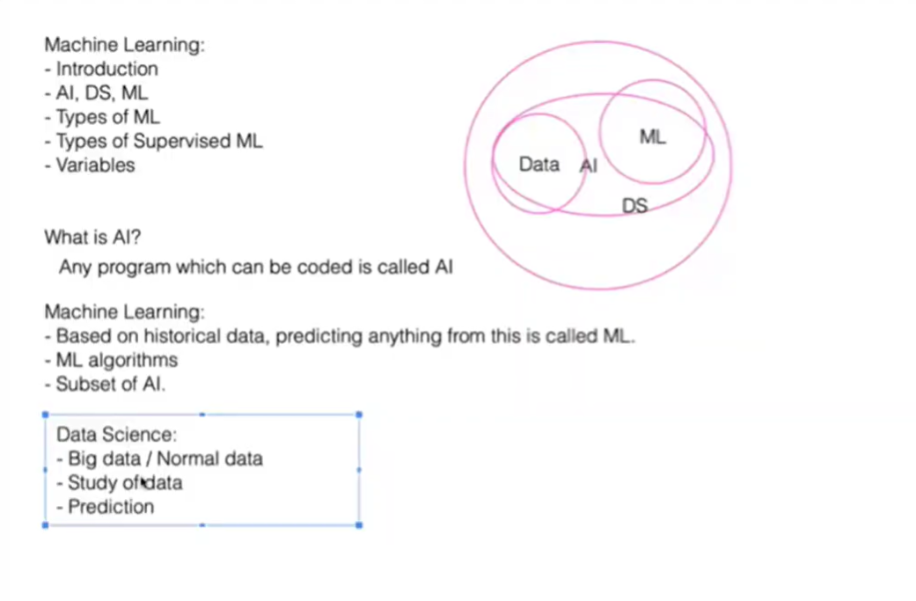

Machine Learning:
- Introduction
- AI, DS, ML
- Types of ML
- Types of Supervised ML
- Variables
What is AI?
Any program which can be coded is called AI
For ex- prime number, any automation in program is called AI
Machine Learning:
- Based on historical data, predicting anything from this is called ML.
- ML algorithms
- Subset of AI.
Data Science:
Combination of data and ML is called data science
- Big data / Normal data
- Study of data
- Prediction

Steps for Building a ML Model

Steps for building a ML model

1. Collecting Data
- Collect the data from various data sources / one source
- CSV, Database, Big Table

2. Data Preparation
- EDA (Visualization)
- Data Cleaning
- Feature Selection
- Feature Engineering
* Normalization
* Creating new features from the existing features
- EDA (Visualization)

3. Train a Model
- Train (80%) & Test Data (20%)
- Train Data
-> Run an algorithm
-> Creates a model for you
-> Save model

4. Evaluate the Model
- Evaluate the trained model on your unseen data / test data
- Test Data (20 rows, 20 outputs (0,1) / y_test)
-> Load Model
-> Prediction (0,1) / y_pred
- Verify the performance and quality of the model
- Accuracy : multiple models to check accurecy
Sklearn: accuracy_score(y_test, y_pred), f1-score, precision,recall,RMSE,RMAE (likely MAE), R² score

5. Improve the Model : if accuracy is less then expected then apply this and re-work on all above steps
- >= 70% Accuracy

Types of Machine Learning Algorithms

1. Supervised ML Algos
- Where we have features + output variable
- Features / Columns -> Output (two or more than two values)
- Examples:
• Email Classification
• Image Classification
• House Price Prediction

2. Unsupervised ML Algos
- Input + no output variables
- Grouping / Clustering-based models
- Examples:
• Identifying categories based on text
• Shape identification through clustering
• Document Clustering
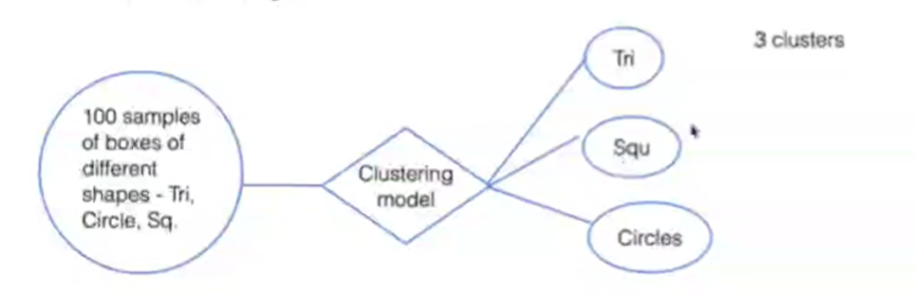

3. Reinforcement Learning
- Specific Decision
- Reward / Feedback
- To maximize the quality of the model
- Examples:
• Self Driving Cars
• Gaming

Supervised Learning model

• Predict / Target output -> Real values. Floating values

• Linear -> Relationship between independent and dependent variables.

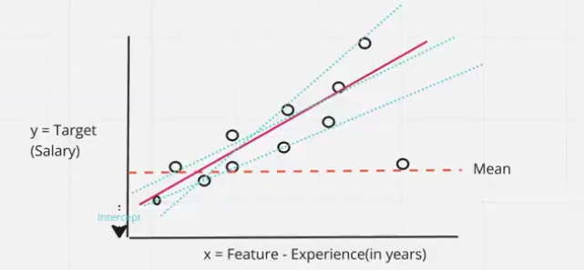

Coefficients:

• Intercept - B0 - b = Constant

• Slope - B1 - m

• y = b + mx = b0 + b1x

• if exp(x1) is 0 => y = b0 + b1x1
=> y = 10000 + 4*0
=> y = 10000 + 0
=> y = 10000
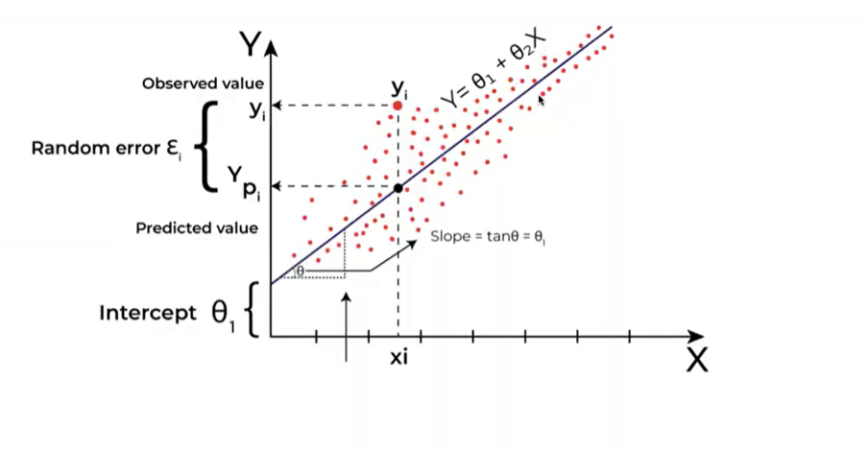
• To find the best line
• We have to estimate the value for the coefficients.

Slop b or b1 = formula of slop

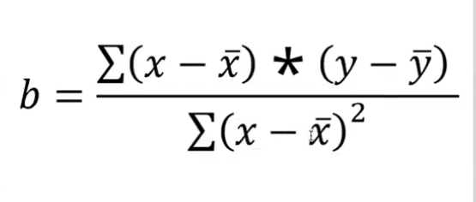

Intercept - B0 - b = Constant = formula of constant
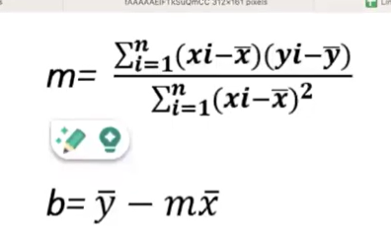

:>m is slop

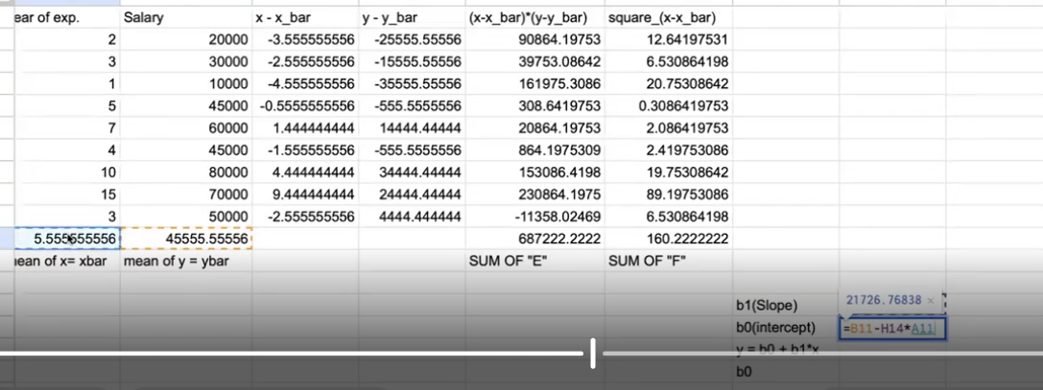

Error rate??

• SSE = Sum of Square Error

• SST = Sum of Square Total

• SSR = Sum of Square due to Regression
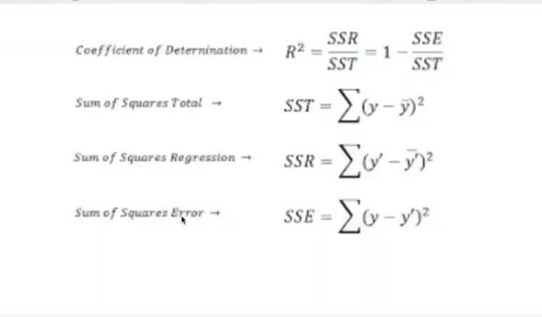
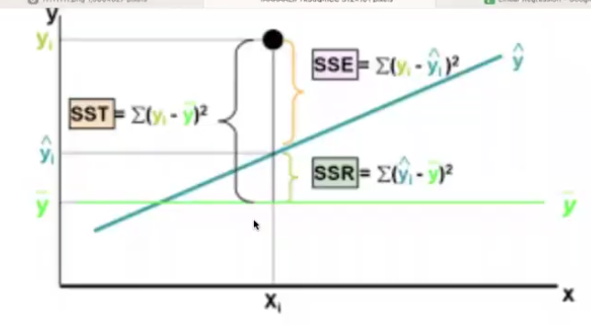

Evaluation metrics:

• RMSE

• Root mean square error

• MSE = SSE / num_samples

• RMSE = Square root of MSE.

• MAE (RMAE == MAE:

• Mean absolute error / Relative mean absolute error

• MAE = AE / num_samples

• Why do we take root in MAE?

• I think it seems like a misunderstanding, AFAIK rMAE is
"relative Mean Absolute Error" not "root Mean Absolute Error"
and as a result it has no unit (e.g. dollars)

• Industry standard - We use RMSE over MAE.
(considering outlier in the dataset)

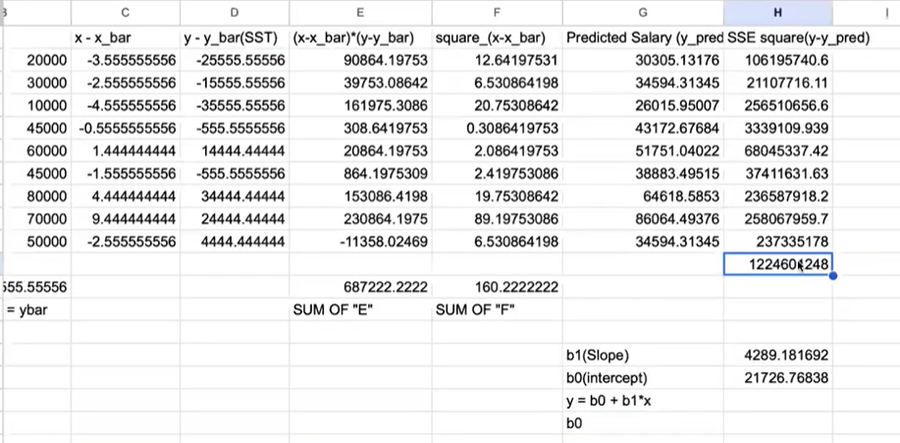
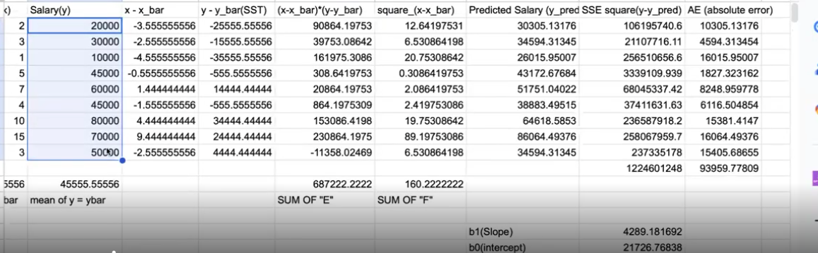

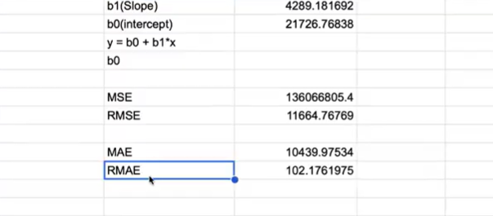

R-squared : for testing the model how much accurate

• Coefficient of determination

• 0 to 100%

• It measures how well your model fits the data.

• 0% = Regression line

• 70% =

• 100% =

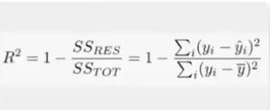

EX:
5 features:

• 1st feature (exp.) = 60% explain => 70% (R2-squared)
• 2nd feature (company_type) = 30% => 90%
• 3rd feature (age) = 5% => 92%
• 4th feature (college) = 4% => 93%
• 5th feature (gender) = 0.8% => 93.5%
• 6th feature (area) = 0.2% => 94%
• Target = Salary

Drawback of R2 -> Even adding irrelevant/weak feature to the model, the
value of r2 will keep increasing.

To overcome this problem: Adjusted R-squared.

• To help solving the issue of overfitting which we generally in r-square
• Penalise the model if we add weak feature.
R-squre formula
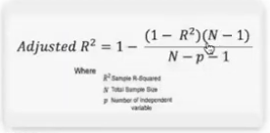
Gradient Descent: best coefficient find karne k liye
- Optimisation Algorithm
- To find the best values of the coefficient/weights to minimise the error rate.
  - Random weights / coefficients
  - Learning rate - size of Steps
Type of Gradient Descent:
• Batch - Use samples at once. If data is very large 10M
• Stochastic - One at a time. 1M
• Mini-Batch - Takes mini batches at a time. 3M

